Clearance Gap

Definition
# Source: AI Source: Provided by: [Data Path: Persons Table -> ID Column: 1, Name_En Column: Motasem Essam] -> From: [ChatGPT] on [7/25/2026]
A Clearance Gap is the intentional space maintained between two geometric objects, components, surfaces, or boundaries to prevent unwanted contact or interference.
It represents a required or designed minimum separation between objects.
$$\boxed{g_{\text{clearance}}=d\left(A , B\right)}$$
where $d\left(A , B\right)$represents the relevant separation between the objects.
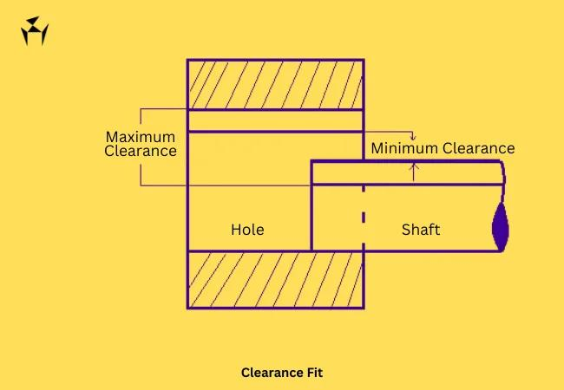
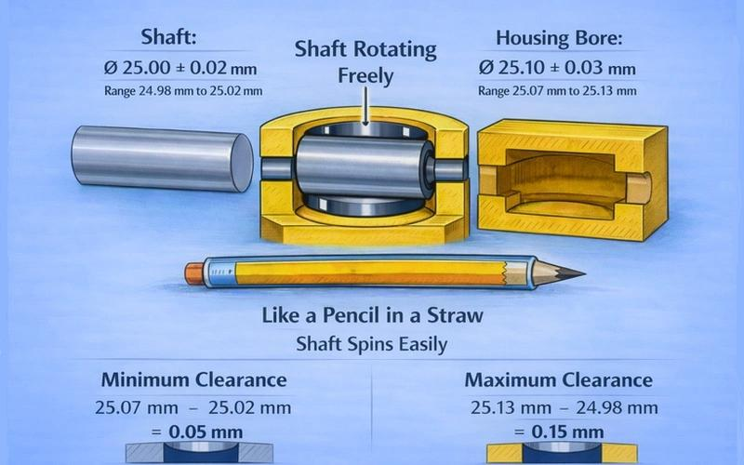
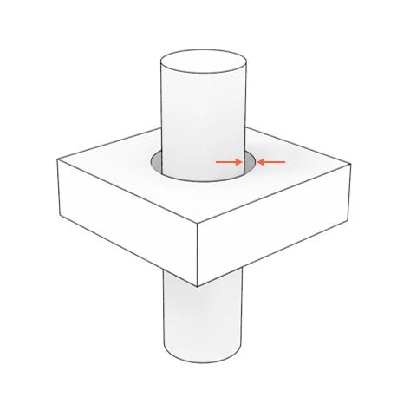
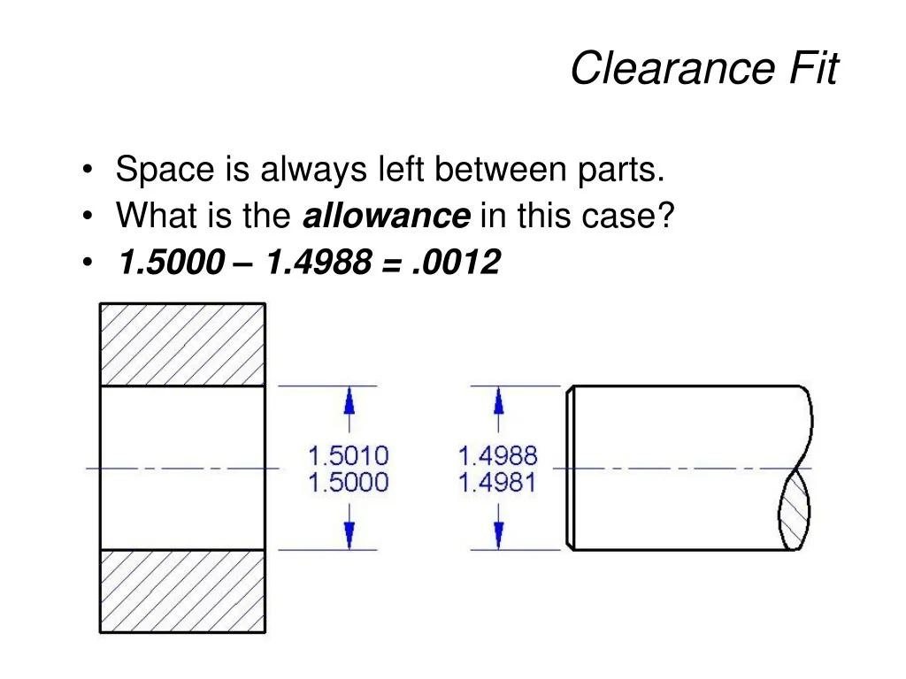
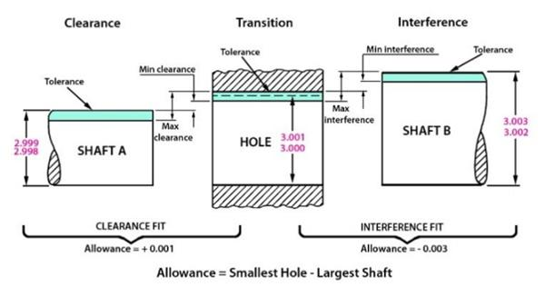

Purpose
# Source: AI Source: Provided by: [Data Path: Persons Table -> ID Column: 1, Name_En Column: Motasem Essam] -> From: [ChatGPT] on [7/25/2026]
A Clearance Gap is used to:
- Prevent two objects from touching.
- Allow movement between components.
- Account for manufacturing tolerances.
- Allow for thermal expansion.
- Prevent interference between moving parts.
- Provide safe or functional spacing.
- Maintain a specified minimum separation.

Fundamental Concept
# Source: AI Source: Provided by: [Data Path: Persons Table -> ID Column: 1, Name_En Column: Motasem Essam] -> From: [ChatGPT] on [7/25/2026]
Consider two components:
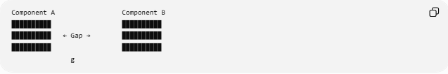
Component A Component B
██████████ ██████████
██████████ ← Gap → ██████████
██████████ ██████████
g
The space $g$is deliberately provided so that the components remain separated.
The important characteristic is that the gap is intentional and functional, rather than simply being an accidental empty space.

Clearance Requirement
# Source: AI Source: Provided by: [Data Path: Persons Table -> ID Column: 1, Name_En Column: Motasem Essam] -> From: [ChatGPT] on [7/25/2026]
A design may specify a minimum clearance:
$$\boxed{g≥g_{min}}$$
where:
- $g$= actual clearance gap
- $g_{min}$= required minimum clearance
For example, if:
$$g_{min}=2\text{ mm}$$
then an acceptable design requires:
$$\boxed{g≥2\text{ mm}}$$

Minimum Clearance
# Source: AI Source: Provided by: [Data Path: Persons Table -> ID Column: 1, Name_En Column: Motasem Essam] -> From: [ChatGPT] on [7/25/2026]
When objects have varying shapes or positions, clearance is often based on the minimum separation between them:
$$\boxed{g_{min}=d_{min}\left(A , B\right)}$$
This is especially important for:
- moving parts,
- curved surfaces,
- irregular objects,
- 3D components.

Clearance Gap vs. Ordinary Gap
# Source: AI Source: Provided by: [Data Path: Persons Table -> ID Column: 1, Name_En Column: Motasem Essam] -> From: [ChatGPT] on [7/25/2026]
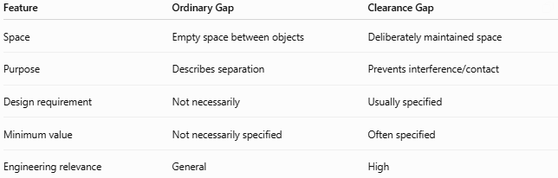
Feature | Ordinary Gap | Clearance Gap
Space | Empty space between objects | Deliberately maintained space
Purpose | Describes separation | Prevents interference/contact
Design requirement | Not necessarily | Usually specified
Minimum value | Not necessarily specified | Often specified
Engineering relevance | General | High
For example:
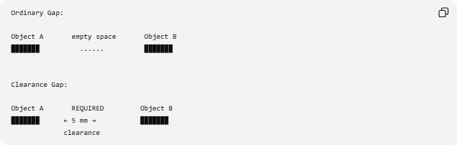
Ordinary Gap:

Object A empty space Object B
███████ ...... ███████

Clearance Gap:

Object A REQUIRED Object B
███████ ← 5 mm → ███████
clearance

Clearance Gap vs. Boundary Gap
# Source: AI Source: Provided by: [Data Path: Persons Table -> ID Column: 1, Name_En Column: Motasem Essam] -> From: [ChatGPT] on [7/25/2026]
A Boundary Gap describes the separation between boundaries.
A Clearance Gap describes a separation that is maintained for a functional purpose.
Therefore, the two concepts can overlap:
$$\boxed{\text{Clearance Gap}⊆\text{Gap}}$$
and a clearance gap can also be a boundary gap when the relevant objects are defined by their boundaries.

Types of Clearance Gaps

1. Static Clearance Gap
# Source: AI Source: Provided by: [Data Path: Persons Table -> ID Column: 1, Name_En Column: Motasem Essam] -> From: [ChatGPT] on [7/25/2026]
A gap maintained between objects that remain stationary relative to each other.
Example:
Wall Clearance Structure
█████ ← 20 mm → █████

2. Moving-Part Clearance Gap
# Source: AI Source: Provided by: [Data Path: Persons Table -> ID Column: 1, Name_En Column: Motasem Essam] -> From: [ChatGPT] on [7/25/2026]
A gap that allows one component to move without contacting another.
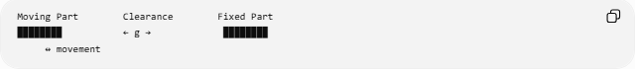
Moving Part Clearance Fixed Part
████████ ← g → ████████
↔ movement

3. Thermal Expansion Gap
# Source: AI Source: Provided by: [Data Path: Persons Table -> ID Column: 1, Name_En Column: Motasem Essam] -> From: [ChatGPT] on [7/25/2026]
A gap provided to accommodate expansion caused by temperature changes.
If an object expands by $ΔL$, the available clearance must account for the expected expansion.
A simplified condition is:
$$\boxed{g_{\text{initial}}≥ΔL}$$
when the gap is intended to accommodate expansion toward the neighboring object.

4. Assembly Clearance Gap
# Source: AI Source: Provided by: [Data Path: Persons Table -> ID Column: 1, Name_En Column: Motasem Essam] -> From: [ChatGPT] on [7/25/2026]
A gap that allows components to be assembled or inserted.
For example, a shaft may need sufficient clearance to enter a hole.

5. Safety Clearance Gap
# Source: AI Source: Provided by: [Data Path: Persons Table -> ID Column: 1, Name_En Column: Motasem Essam] -> From: [ChatGPT] on [7/25/2026]
A minimum separation maintained to reduce the possibility of unwanted contact or interference.

Clearance and Tolerance
# Source: AI Source: Provided by: [Data Path: Persons Table -> ID Column: 1, Name_En Column: Motasem Essam] -> From: [ChatGPT] on [7/25/2026]
Clearance is closely related to tolerance, but they are not the same.
- Clearance = intentional space between mating or neighboring features.
- Tolerance = permitted variation in a dimension.
For example, suppose a shaft has diameter:
$$D_{s}=20.00\text{ mm}$$
and a hole has diameter:
$$D_{h}=20.10\text{ mm}$$
The diametral clearance is:
$$C=D_{h}-D_{s} \\ C=20.10-20.00 \\ \boxed{C=0.10\text{ mm}}$$
The actual clearance can vary because the dimensions themselves have tolerances.

Example: Two Parallel Surfaces
# Source: AI Source: Provided by: [Data Path: Persons Table -> ID Column: 1, Name_En Column: Motasem Essam] -> From: [ChatGPT] on [7/25/2026]
Suppose two parallel surfaces are separated by:
$$g=4\text{ mm}$$
and the required minimum clearance is:
$$g_{min}=3\text{ mm}$$
Since:
$$4≥3$$
the specified minimum clearance is satisfied.

Example: Moving Component
# Source: AI Source: Provided by: [Data Path: Persons Table -> ID Column: 1, Name_En Column: Motasem Essam] -> From: [ChatGPT] on [7/25/2026]
A rotating component has a radius of:
$$r=50\text{ mm}$$
and the surrounding housing has an internal radius of:
$$R=52\text{ mm}$$
The radial clearance is:
$$g=R-r \\ g=52-50 \\ \boxed{g=2\text{ mm}}$$
This 2 mm space allows the component to rotate without contacting the housing, assuming other geometric and tolerance conditions are satisfied.

Clearance Gap and Interference
# Source: AI Source: Provided by: [Data Path: Persons Table -> ID Column: 1, Name_En Column: Motasem Essam] -> From: [ChatGPT] on [7/25/2026]
Clearance and interference represent different relationships.
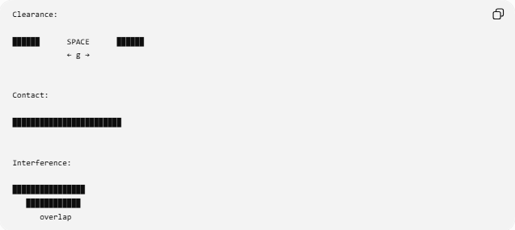
Clearance:

██████ SPACE ██████
← g →

Contact:

████████████████████████

Interference:

████████████████
████████████
overlap
Conceptually:
$$\boxed{g>0→\text{clearance}} \\ \boxed{g=0→\text{contact}} \\ \boxed{g<0→\text{interference}}$$
The last expression is useful as a mathematical convention for dimensional fit analysis, although physically the objects would occupy overlapping space rather than literally having a negative empty gap.

Important Taxonomy Note
# Source: AI Source: Provided by: [Data Path: Persons Table -> ID Column: 1, Name_En Column: Motasem Essam] -> From: [ChatGPT] on [7/25/2026]
Clearance Gap is not purely a geometric type like Point Gap or Linear Gap. It is a functional/design type of gap.
Its defining characteristic is that the separation is intentionally provided to satisfy a requirement.
Therefore:
$$\boxed{\text{Clearance Gap}=\text{Intentional Gap for Functional Separation}}$$

Real-World Applications
# Source: AI Source: Provided by: [Data Path: Persons Table -> ID Column: 1, Name_En Column: Motasem Essam] -> From: [ChatGPT] on [7/25/2026]
Clearance gaps are used in:
- Mechanical engineering — moving and rotating components.
- Manufacturing — fits between mating parts.
- Construction — expansion joints and structural spacing.
- Architecture — required building clearances.
- Electrical engineering — spacing between components.
- Automotive engineering — component and body clearances.
- Aerospace — tight component clearances.
- Robotics — collision-free movement.
- CAD — interference and clearance analysis.

Key Points
# Source: AI Source: Provided by: [Data Path: Persons Table -> ID Column: 1, Name_En Column: Motasem Essam] -> From: [ChatGPT] on [7/25/2026]
- A Clearance Gap is an intentionally maintained separation.
- Its purpose is generally to prevent contact or interference.
- A minimum requirement can be expressed as:
$$\boxed{g≥g_{min}}$$
- Clearance is closely related to tolerance and fit.
- It can be linear, boundary-based, or surface-based.
- Unlike an ordinary gap, clearance has a functional or design purpose.

Conclusion
# Source: AI Source: Provided by: [Data Path: Persons Table -> ID Column: 1, Name_En Column: Motasem Essam] -> From: [ChatGPT] on [7/25/2026]
A Clearance Gap is an intentionally designed space between geometric objects, components, or surfaces that provides sufficient separation for movement, assembly, thermal expansion, safety, or other functional requirements. It is therefore best understood as a purpose-based type of gap, rather than simply a geometric measurement.

